Одесский Национальный Политехнический Университет

Кафедра информационных систем

Лабораторная работа № 11

по дисциплине: «Веб-технологии и веб-дизайн»

## на тему «Создание динамических страниц с помощью PHP»

Выполнил:

Ст. группы АИ-166

Дидух Э. Г.

Проверили:

Червоненко П. П.

Панькина А. С.

Одесса, 2018

**ЗАДАНИЕ НА ЛАБОРАТОРНУЮ РАБОТУ:**

Цель работы: формирование умений использования PHP

Практические задания

Задание 1

Создать новую страницу применив PHP вместо SSI.(Страница должна иметь вид главной

страницы небольшого сайта)

Сделайте, чтобы cookie передавались не с помощью META - данных, а с помощью setcookie (указав свою фамилию, имя).

Проверьте работоспособность на сервере.

Задание 2

Создайте счетчик посещаемости страниц (файл count.inc). Для записи файлов со значением счетчика, используйте каталог counter (он у вас уже создан!!!).

Вставьте его с помощью include в (Фамилия).php.

Проверьте работоспособность на сервере.

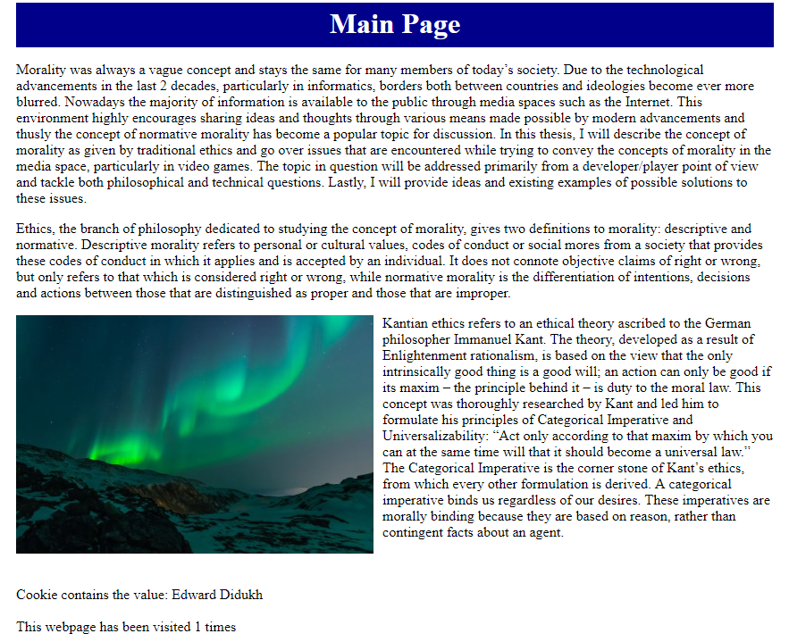

|  |
| --- |
| <?php  setcookie("student", "Edward Didukh");  $student;  ?>  <html lang="en">  <head>  <meta charset="UTF-8">  <title>Lab_11</title>  </head>  <body>  <div style="width: 90%; height: 50px; position: relative; left: 5%; background-color: darkblue; color: white;">  <h1 align="center" style="padding: 5px;">Main Page</h1>  </div>  <div style="width: 90%; position: relative; left: 5%;">  <p>  Morality was always a vague concept and stays the same for many members of today’s society. Due to the technological advancements in the last 2 decades, particularly in informatics, borders both between countries and ideologies become ever more blurred. Nowadays the majority of information is available to the public through media spaces such as the Internet. This environment highly encourages sharing ideas and thoughts through various means made possible by modern advancements and thusly the concept of normative morality has become a popular topic for discussion. In this thesis, I will describe the concept of morality as given by traditional ethics and go over issues that are encountered while trying to convey the concepts of morality in the media space, particularly in video games. The topic in question will be addressed primarily from a developer/player point of view and tackle both philosophical and technical questions. Lastly, I will provide ideas and existing examples of possible solutions to these issues.  </p>  <p>  Ethics, the branch of philosophy dedicated to studying the concept of morality, gives two definitions to morality: descriptive and normative. Descriptive morality refers to personal or cultural values, codes of conduct or social mores from a society that provides these codes of conduct in which it applies and is accepted by an individual. It does not connote objective claims of right or wrong, but only refers to that which is considered right or wrong, while normative morality is the differentiation of intentions, decisions and actions between those that are distinguished as proper and those that are improper.  </p>  <img src="https://www.w3schools.com/w3css/img_lights.jpg" style="width: 400px; float: left; margin-right: 10px;">  <p>  Kantian ethics refers to an ethical theory ascribed to the German philosopher Immanuel Kant. The theory, developed as a result of Enlightenment rationalism, is based on the view that the only intrinsically good thing is a good will; an action can only be good if its maxim – the principle behind it – is duty to the moral law. This concept was thoroughly researched by Kant and led him to formulate his principles of Categorical Imperative and Universalizability:  “Act only according to that maxim by which you can at the same time will that it should become a universal law.”  The Categorical Imperative is the corner stone of Kant’s ethics, from which every other formulation is derived. A categorical imperative binds us regardless of our desires. These imperatives are morally binding because they are based on reason, rather than contingent facts about an agent.  </p>  <br>  <br>  <?php  echo "Cookie contains the value: ";  echo $_COOKIE["student"];  echo "<br>";  echo "<br>";  include "counter.php";  ?>  </div>  </body>  </html> |

**Выводы:** В данной лабораторной работе мы ознакомились c принципом создания динамических страниц с помощью РНР. С помощью полученных знаний создали несколько тестовых HTML-страниц для проверки работы предоставленных в методических указаниях PHP-скриптов, следовательно цель работы достигнута.